Full Name: ……………………………………………………………………………….
Preferred Name: ………………………………

Contact Details:
Address: ……………………………………………………………………………………………………………
………………………………………………………………………………………. Postcode: ……………….
Telephone Number: ……………………………………………………..
Mobile Number: ……………………………………………………..
Email: ………………………………………………………

Facebook/Messenger WhatsApp (please note: these might not be available)

Media Permission:
I give / do not give [delete as required] permission for photos of me to be taken at church by our official photographers to be used for this church’s publicity (church magazine, circuit newsletter, Facebook, Methodist websites).
I am aware that the circuit will always ensure the pictures are respectful in their nature and appropriate to the activity promoted, and that no link can be made between your image and your full name, address, email, etc. to avoid personal information being displayed or accessed publicly.
Role/Office holders: Please give permission by ticking the relevant boxes
In order for role and office holders to practically fulfil their duty it is strongly recommended that permission is given to have preferred details made public.
Role/Office held Preferred Public Contact Date Ticked
Supernumerary Tel. Mob. Email ………………..
Safeguarding Officer Tel. Mob. Email ………………..
Local Preacher Tel. Mob. Email ………………..
Worship Leader Tel. Mob. Email ………………..
Music operator Tel. Mob. Email ………………..
Circuit Steward Tel. Mob. Email ………………..
Circuit Treasurer Tel. Mob. Email ………………..
Other: ………………………… Tel. Mob. Email ………………..

Explanation:
In order for the Methodist Church to fulfil its commitments to its members and adherents it requires certain information to operate. We require your full name because in the unfortunate incident that you are admitted to hospital we may need your full name to prove that we know you and to help the receptionist to identify you amongst others of a similar name. The first line of your home address is also often required.

Please fill out the contact details as much as you are able, in this section this is in order to provide pastoral care which will be held confidentially by the pastoral team (which will include the minister and any relevant lay worker) and may include Methodist church related publicity and wider information depending on your role.

It is strongly advised that if you hold a role or office within the local church it may be in your best interest to give permission to share your preferred information and contact details publicly (for example if you are a safeguarding officer it would be important for you to give permission for your preferred contact details to be made public on a poster Or, if you are a Local Preacher for you to give permission for your name to be advertised publicly on the building at the chapel you will be preaching). To help fulfil your role then please fill in the third section of the form and tick which role or roles and permissions and contacts which apply.
Please note: you can decide how you would like to be known in these places and which of your contact details to be used (for example you may wish to only use your title and surname, with your telephone number alone. For example: Steward: Mrs Wesley, Tel. 01937 123456 Or, you may wish only your first name to be used and your email address, Siân, SingingSian@gmail.com, or even just your job role/office held and Telephone number: Property Steward: 01937 123456).

Finally:
To see how the Methodist Church intends to keep your information securely please read our Privacy Policy here: https://www.tmcp.org.uk/about/data-protection/managing-trustees-privacy-notice or speak to your Methodist minister.

Keep up to date:
If you would like to change your contact details at any time then please speak to a member of the pastoral team (Pastoral Secretary, Minister or Lay Worker).
Thanks for helping us keep up to date.
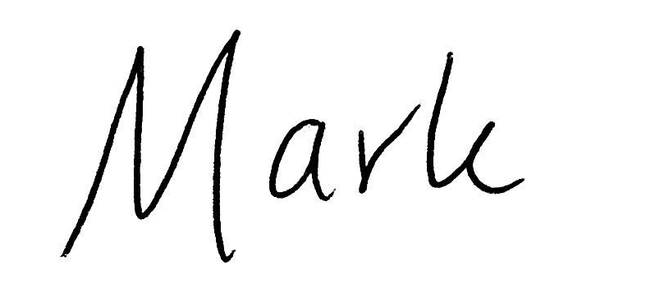
Rev Mark Stennett

